**The Amazing Maze**

1. Create the following background as a bitmap (not a vector).

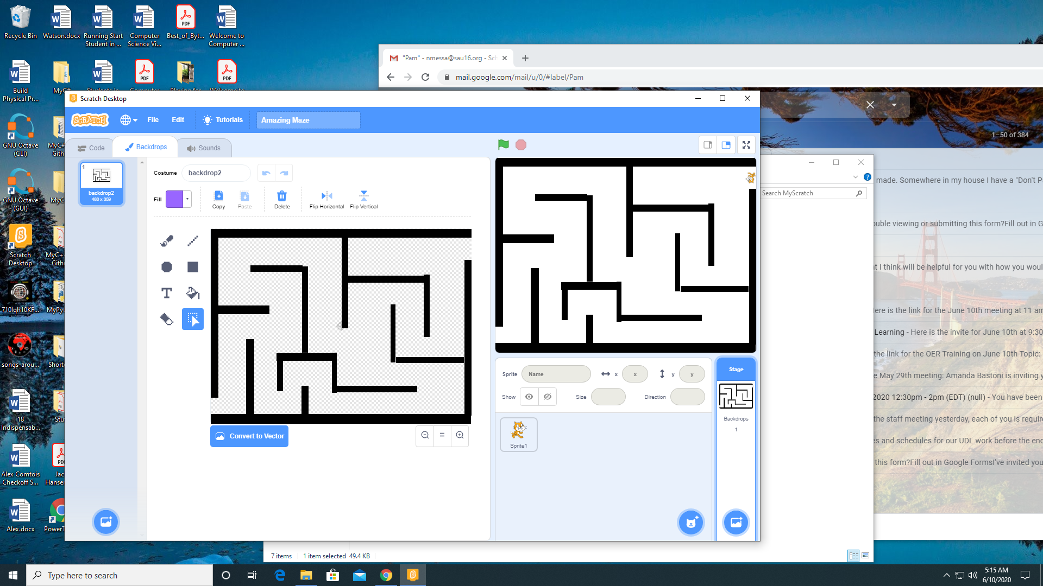

1. Add the following code to Spite 1.

